A and B started from the location below. Both of them try to reach the goal. If one of them reaches the goal, he gets +100 points and the other gets 0 points and the game ends. If both of them reach the goal simutanously, they get +50 points respectively. If they try to go across the barrier, 50% of the time they will go through and 50% of the time they end up sticking. If they try to reach a same location except the goal, only one of them can reach that location.

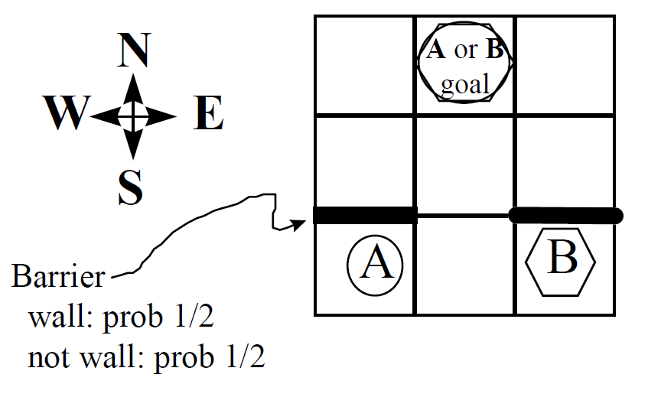

|  |  |  |
| --- | --- | --- |
| 0 | 1 | 2 |
| 3 | 4 | 5 |
| 6 | 7 | 8 |